Chapter 14, Solution 4.

Find the transfer function H(s) = V_{o}/V_{i} of the circuits shown in Fig. 14.71.

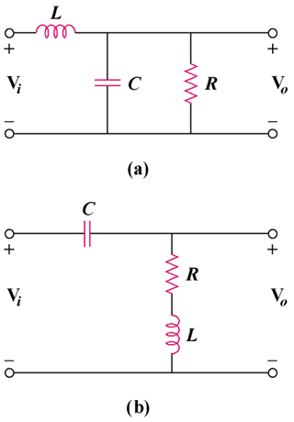

Figure 14.71
For Prob. 14.4.

Solution

